# Jenkins to LDAP integration

## 1 jenkins setup

* Install Ldap plugin
* After installation ->manage Jenkins🡪security🡪Configure global security
* Choose Ldap option

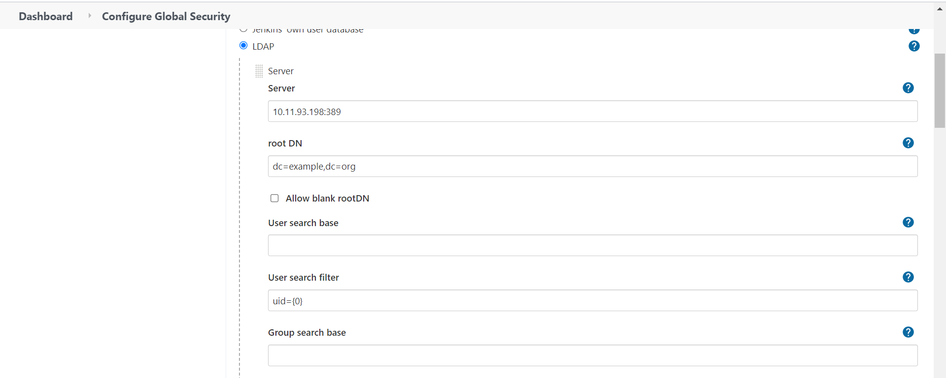

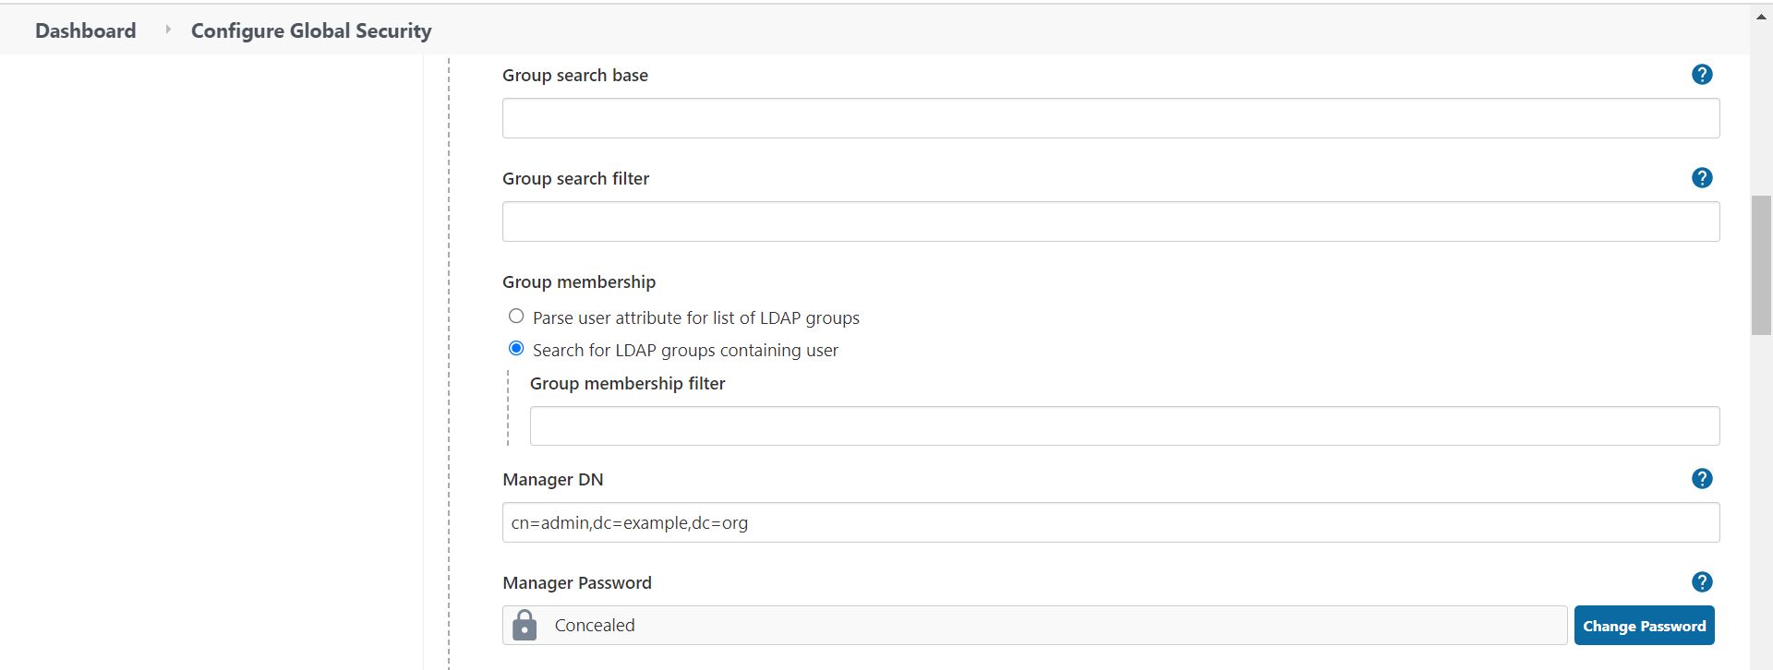

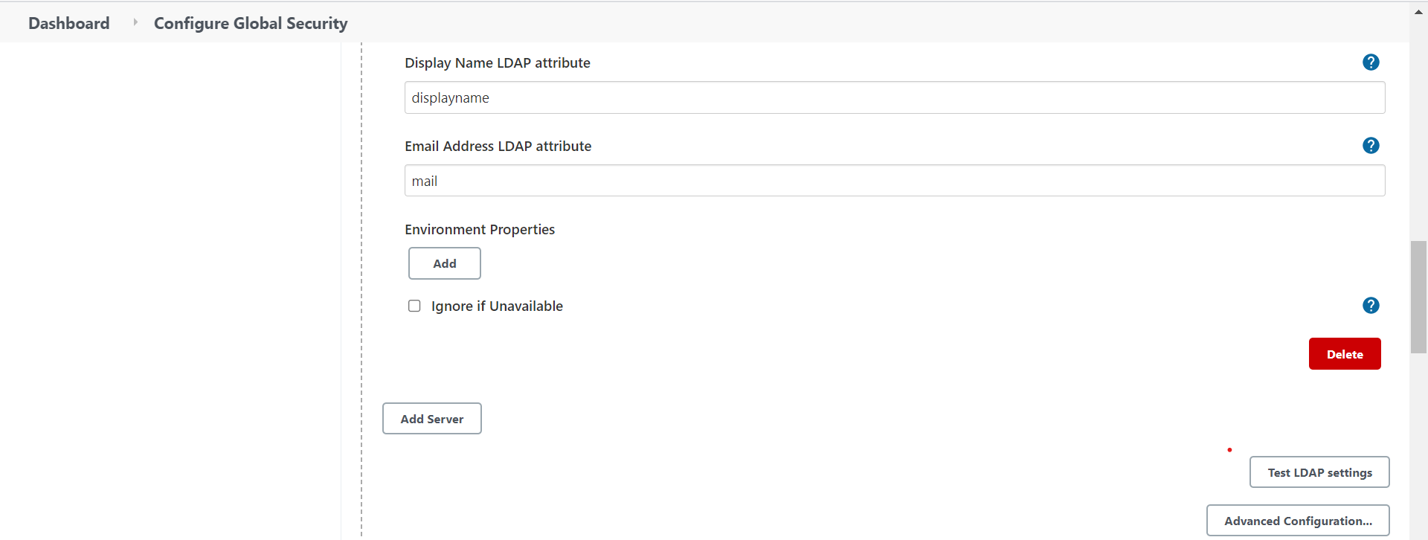

* After setup click Test connection and check it Ldap to Jenkins

## 2 . Ldap setup

* Login to Ldap

User: cn=admin,dc=example,dc=org

Password: secret

* Create users and groups

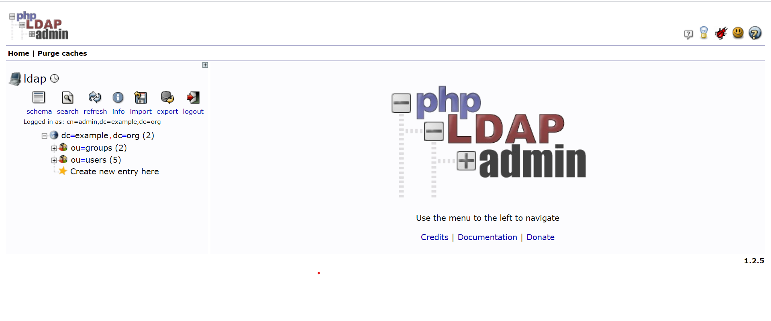

* User creation
* Create new entry here
* Courier mail account

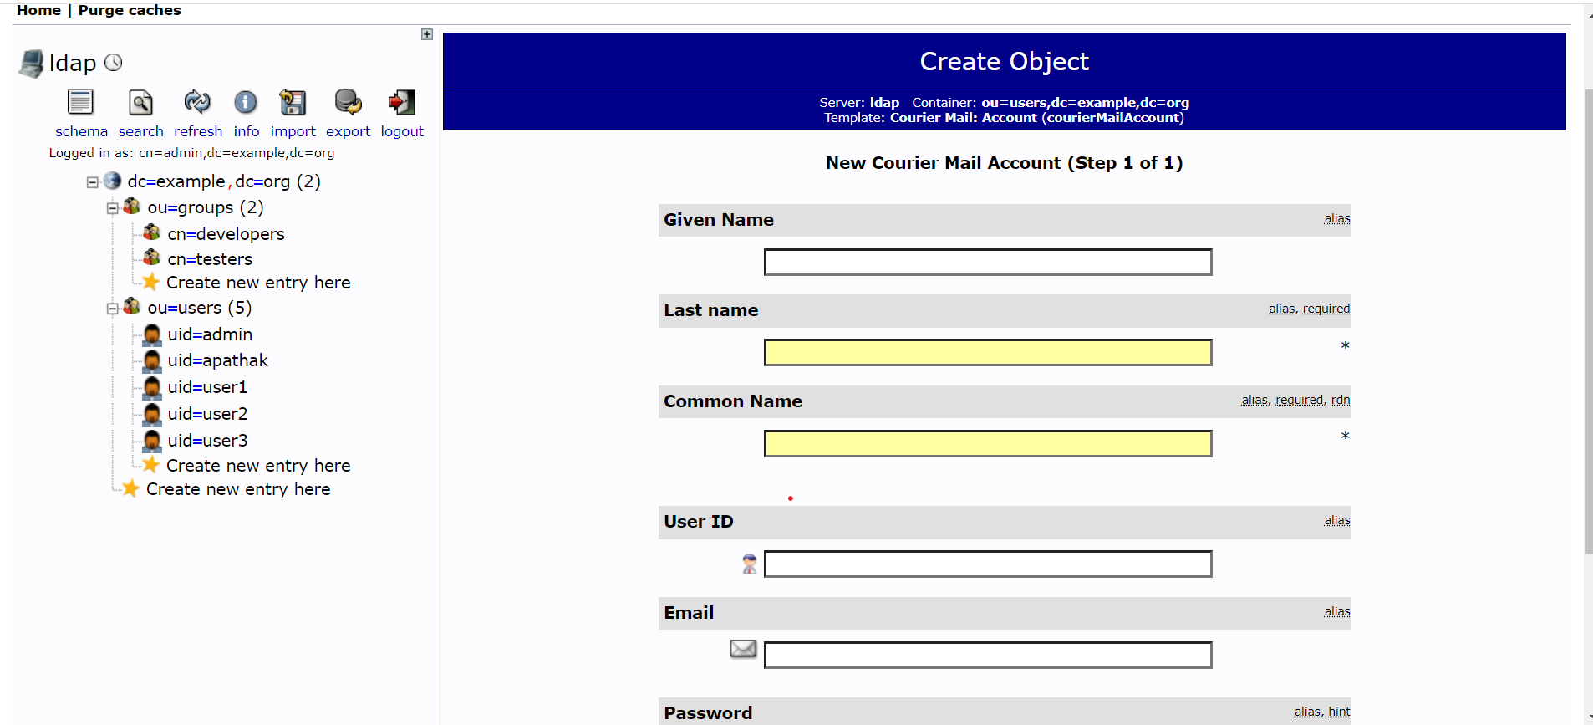

NOTE: Role Based statergy document refer for users wise project access